Library Maintenance API Documentation

Library activity fetch API:

http://127.0.0.1:5000/library_activity_overall?library_id=1

Method: GET

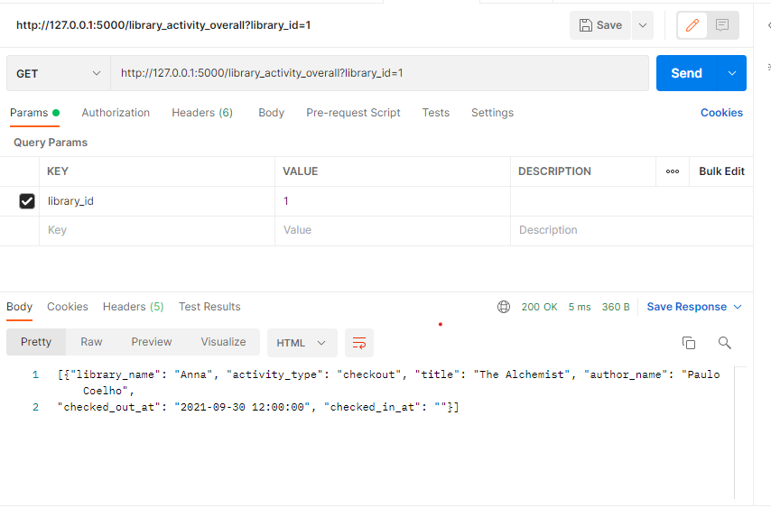

User Activity Fetch API:

<http://127.0.0.1:5000/library_activity_user?name=radhamani>

method: GET

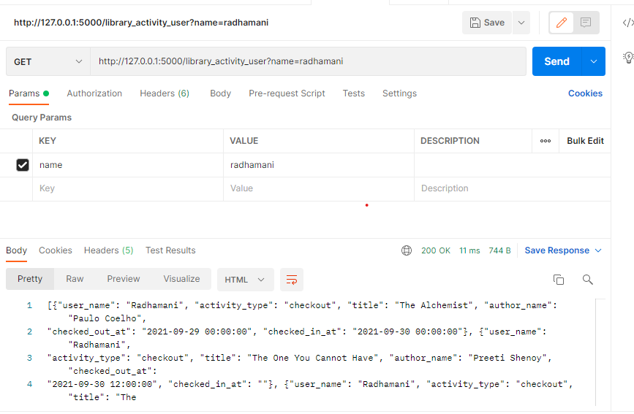

Library book update API:

<http://127.0.0.1:5000/library_book_update?book_id=3&library_id=2>

method POST

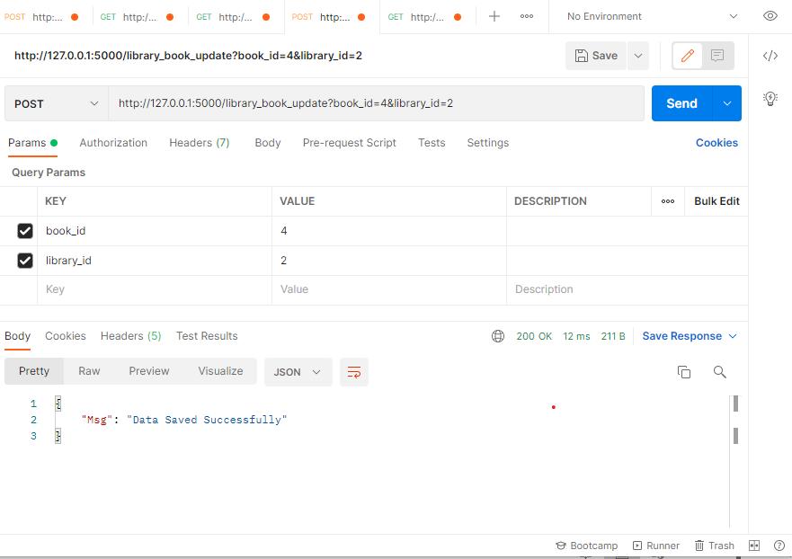

Library Activity update API:

http://127.0.0.1:5000/library_activities?activity_type=checkout&user_id=1&library_book_id=4&checked_out_at=2021-09-30 12:00:00&checked_in_at=

method POST

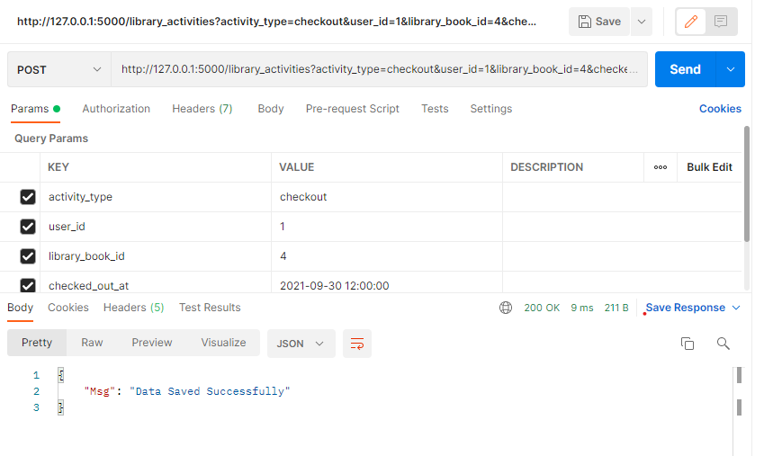

Book update API

http://127.0.0.1:5000/book_update?title=The Cellist&author_name=Daniel Silva&genre=Crime %26 Thriller&isbn_num=000848788X&description=description

method POST

